Name: _____________________________________
Big Rocks

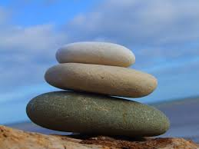

What are the Big Rocks in your life?
Remember to put these Big Rocks in first or you’ll never get them in at all.
What are the pebbles and sand?
