Body Image Reflection Activity Name:___________________________________

Common Body Image Assumptions:

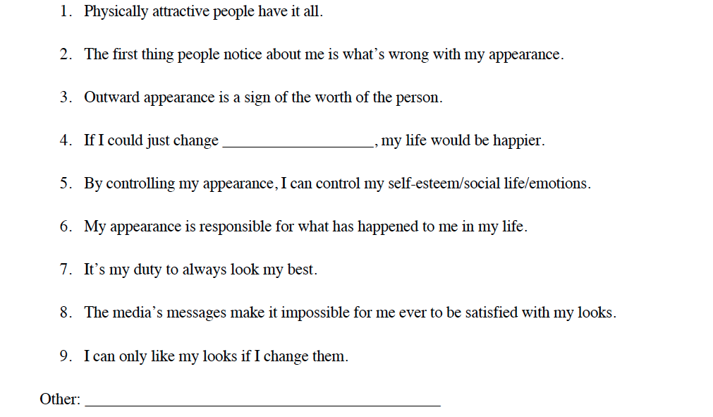

Goal Setting – Transforming your Body Image

How is transforming your body image different from transforming your body?
When you dislike your looks, it is understandable that you want to change what you look like. You probably have spent a lot of time thinking about the ways you would like to change your body, from dieting to having plastic surgery. Changing your body image involves an attitude adjustment instead of an appearance adjustment. It means feeling at home in your own skin rather than feeling separated from your own body.

What is body image?
Body image is not what you look like. It has to do with your personal relationship with your
body, which includes your:
- Thoughts
- Beliefs
- Perceptions
- Feelings
- Actions

