Putting 1st things 1st Weekly Plan For:________________________
Week of:

My Mission Statement:

Short Term Goal | Long Term Goal
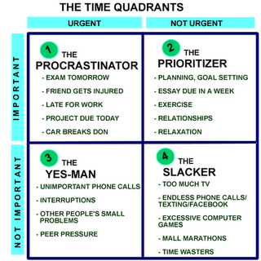
Big Rocks This Week:

To Do List:

Monday | Tuesday | Wednesday | Thursday | Friday | Saturday | Sunday

End of week reflection:

